NEXTAG COMPANY

CALVIN KEILN - MONOGRAM LOGO TRIFOLD WALLET

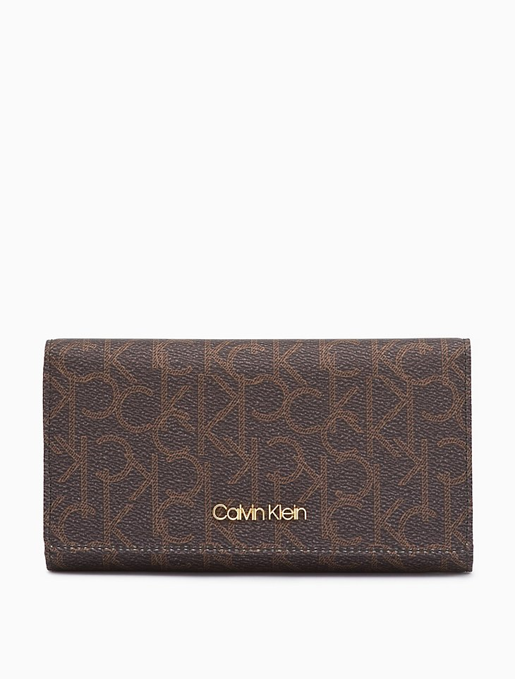

PRODUCT DETAILS

A spacious silhouette with an allover ck monogram design, this iconic trifold wallet is made with water-resistant, subtly textured faux leather. Features a top flap closure with a logo plaque, an exterior back zip pocket, an interior zip pocket, multiple card slots and an id window.

• Monogram logo trifold wallet

• Top flap + logo plaque

• Snap closure

• Exterior back zip pocket

• Interior zip pocket

• 8 card slots + 1 id window

• Fully lined

Style #: 37304215   
Universal Style #: H6GOJ833